**In this article I share step-by-step screenshots showing how you can add a new website (property) in Google Analytics under an existing account.**

### Step 1

Go to <https://www.google.com/analytics/> and click on Access Google Analytics at the top right.



Step 2

Once you are logged in, click on Admin at the top.

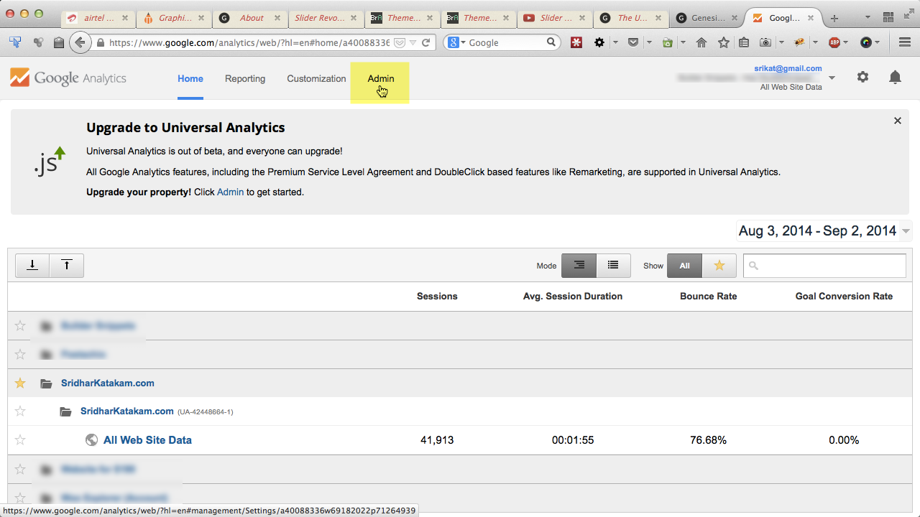

### Step 3

Click on the Account dropdown and select the account under which you would like to add a new website.

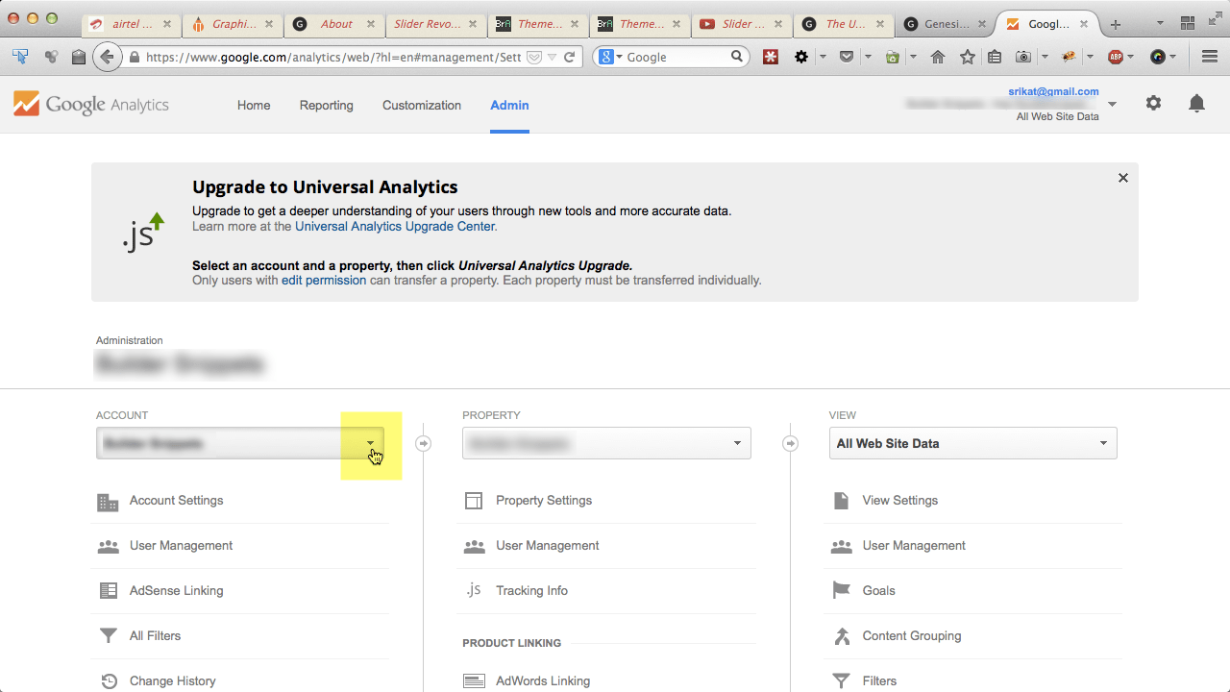

And

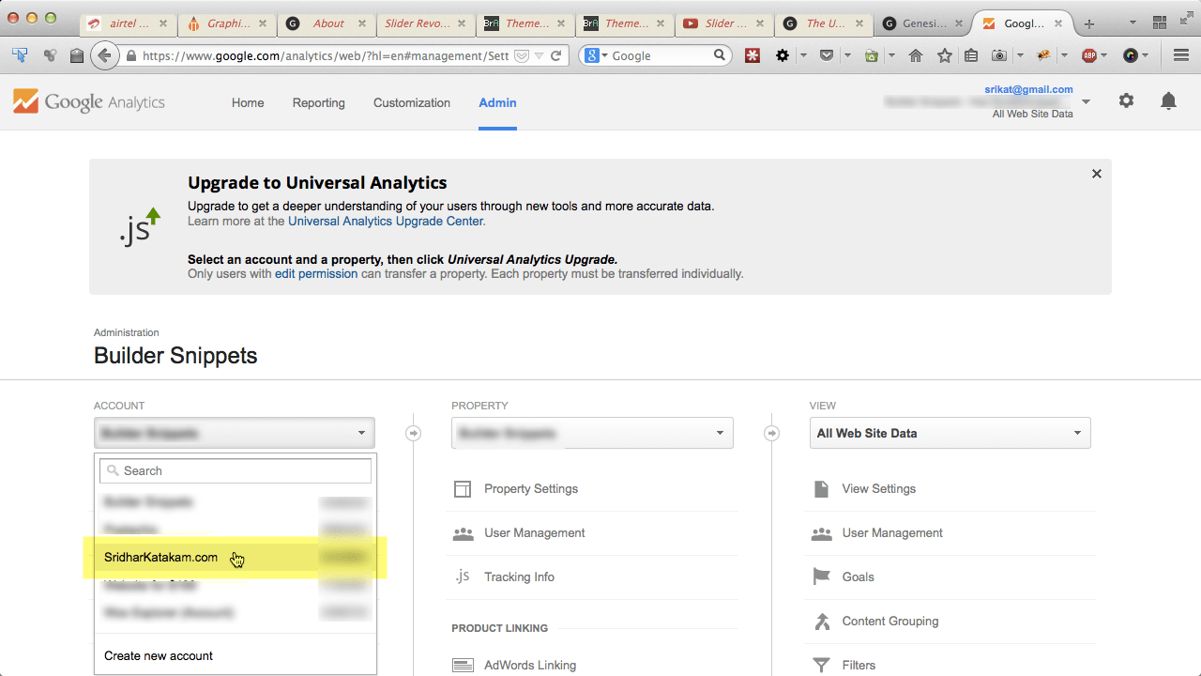

### Step 4

In the middle Property column, click on the dropdown and Create new property.

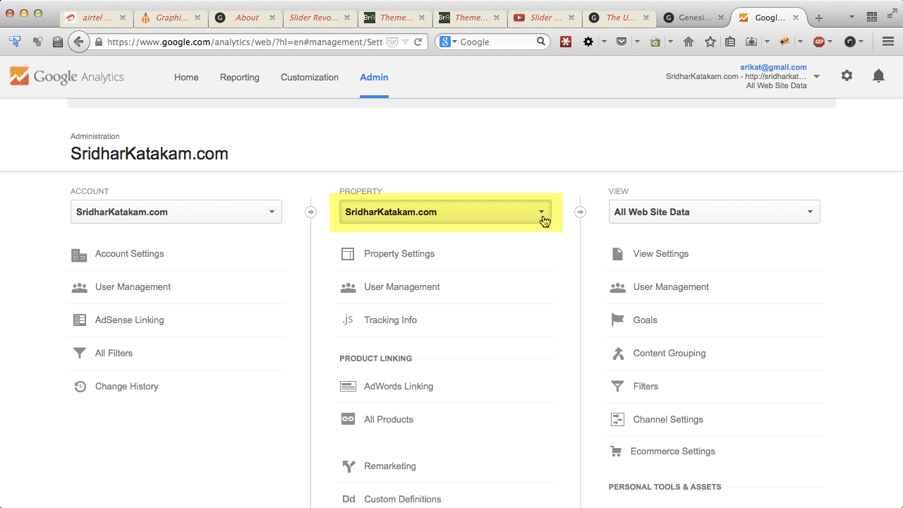

And

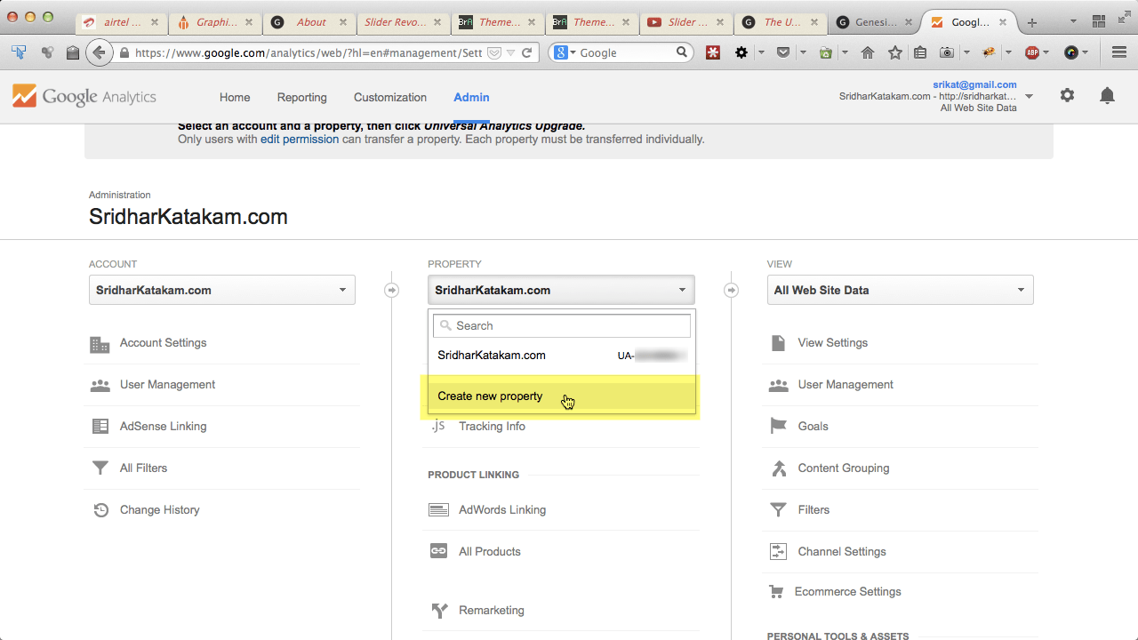

### Step 5

Fill in your website details and click Get Tracking ID button.

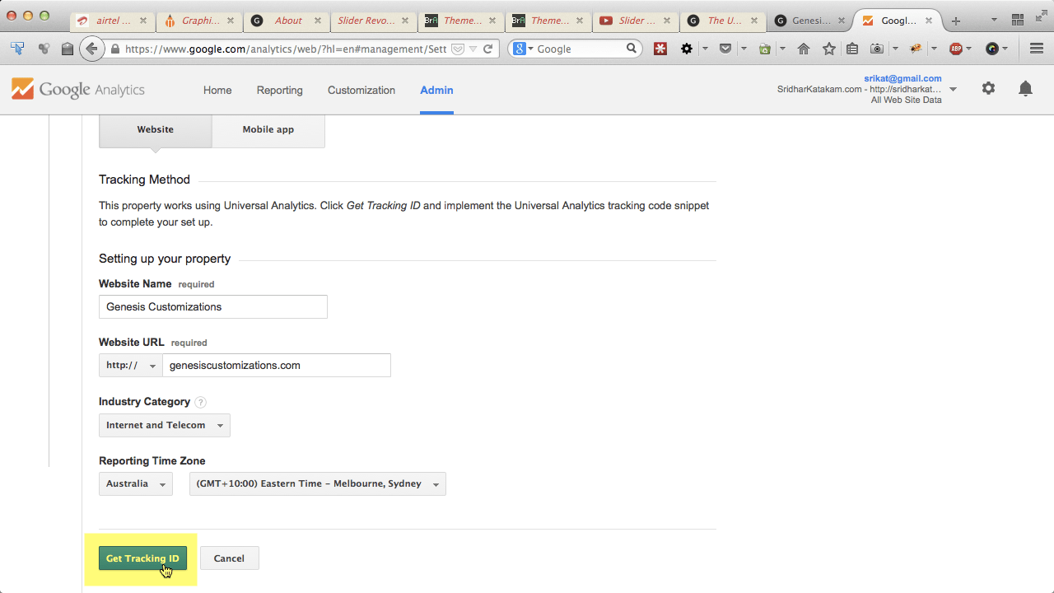

That’s it.

You should now see the Tracking ID and tracking code.

